Lab10
Q3 (a)
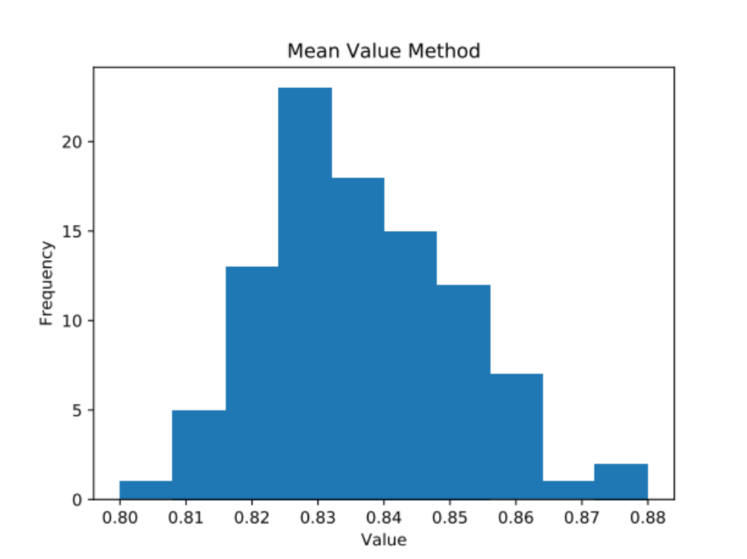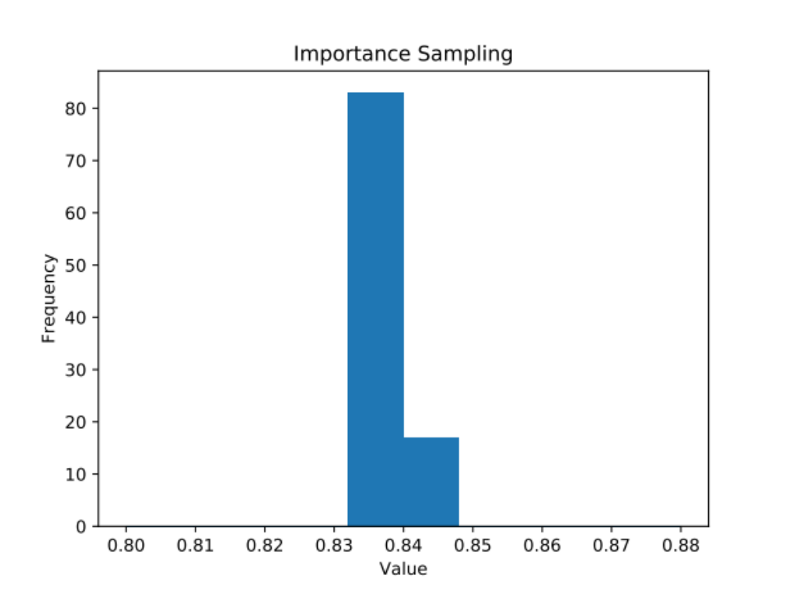

By comparing these two graphs, obviously the latter provides a more accurate prediction. The spreading, which is also consider as error, is much more smaller. 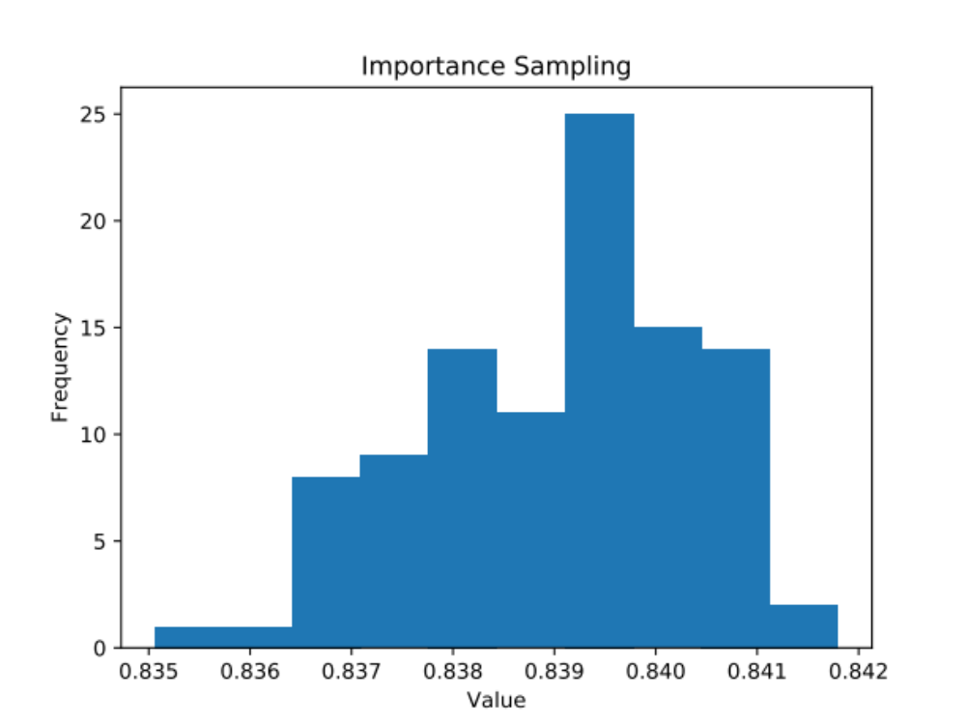
When we cancel out the bin, we can see that indeed there is some error on the calculation but rather small, and very close to the answer provided from the internet 0.8389.

